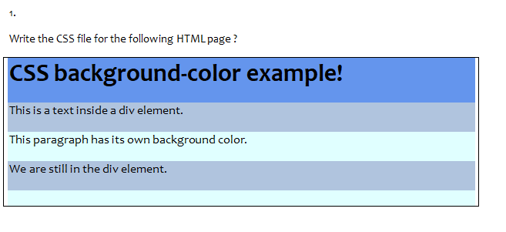

<html>

<head>

    <style>

        h1 {

            background-color:steelblue;

        }

        p {

            background-color:slategray;

        }

        p {

            background-color:skyblue;

        }

        p {

            background-color:cadetblue;

        }

    </style>

</head>

<body>

    <h1>CSS background-color example!</h1>

    <p>This is a text inside a div element.</p>

    <p>This paragraph has its own background color.</p>

    <p>We are still in the div element.</p>

</body>

</html>

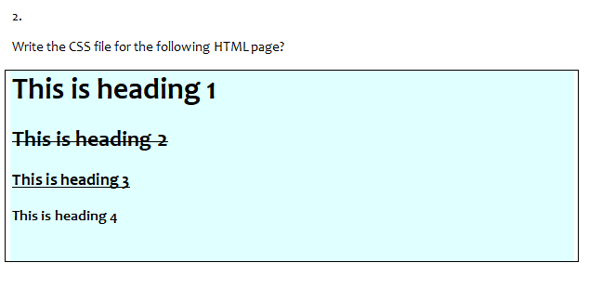

<html>

<head>

    <style>

        h1 {

            text-decoration:none;

        }

        h2 {

            text-decoration:line-through;

        }

        h3 {

            text-decoration:underline;

        }

        h4 {

            text-decoration:none;

        }

    </style>

</head>

<body bgcolor="skyblue">

    <h1>This is heading 1</h1>

    <h2>This is heading 2</h2>

    <h3>This is heading 3</h3>

    <h4>This is heading 4</h4>

</body>

</html>

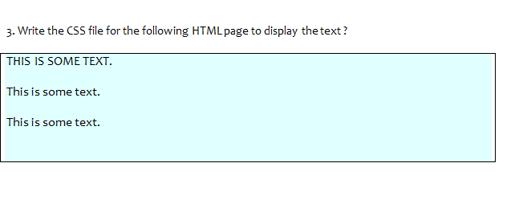

<html>

<head>

    <style>

       p2 {

            font-size:18px;

       }

       p3 {

            font-size:18px;

       }

    </style>

</head>

<body bgcolor="skyblue">

    <p1>THIS IS SOME TEXT.</p1><br>

    <p2>This is some text.</p2><br>

    <p3>This is some text.</p3><br>

</body>

</html>

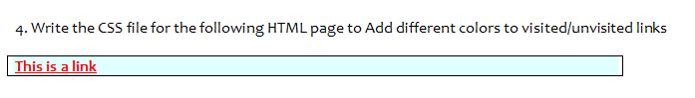

<html>

<head>

    <style>

        a {

            text-decoration:underline;

            color:red;

        }

    </style>

</head>

<body>

   <a href="">This is a link</a>

</body>

</html>

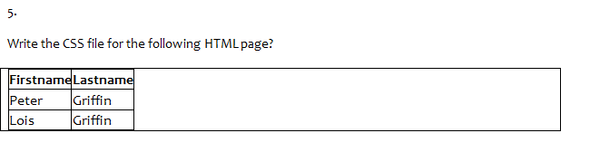

<html>

<head>

    <style>

        table,th,td {

            border:1px solid black;

        }

        table {

            border-collapse: collapse;

        }

    </style>

</head>

<body>

   <table>

        <tr>

            <th>Firstname</th>

            <th>Lastname</th><br>

        </tr>

        <tr>

            <td>Peter</td>

            <td>Griffin</td><br>

        </tr>

        <tr>

            <td>Lois</td>

            <td>Griffin</td>

        </tr>

   </table>

</body>

</html>

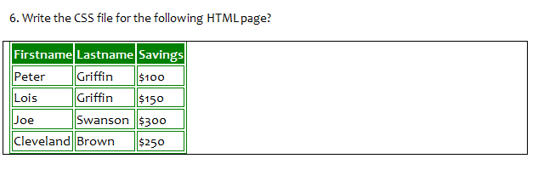

<html>

<head>

    <style>

        table,th,td {

            border:1px solid black;

            border-color: green;

        }

        th {

            background-color:green;

        }

    </style>

</head>

<body>

   <table>

        <tr>

            <th>Firstname</th>

            <th>Lastname</th>

            <th>Savings</th><br>

        </tr>

        <tr>

            <td>Peter</td>

            <td>Griffin</td>

            <td>$100</td><br>

        </tr>

        <tr>

            <td>Lois</td>

            <td>Griffin</td>

            <td>$200</td><br>

        </tr>

        <tr>

            <td>Joe</td>

            <td>Swanson</td>

            <td>$300</td><br>

        </tr>

        <tr>

            <td>Cleveland</td>

            <td>Brown</td>

            <td>$400</td><br>

        </tr>

   </table>

</body>

</html>

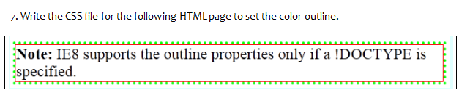

<html>

<head>

    <style>

        p {

            border:dotted green;

        }

        div {

            border:1px solid red;

        }

    </style>

</head>

<body>

    <p><div><b>Note:</b> IE8 supports the outline properties only if a !DOCTYPE is specified.</div></p>

</body>

</html>

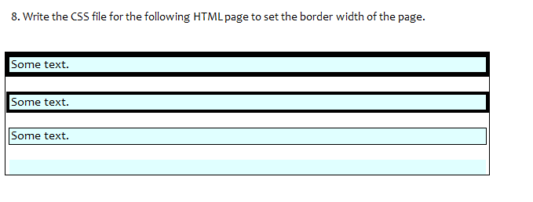

<html>

    <head>

        <style>

            p1 {

                border:4px black solid;

                background-color: skyblue;

            }

            p2 {

                border:3px black solid;

                background-color: skyblue;

            }

            p3 {

                border:1px black solid;

                background-color: skyblue;

            }

        </style>

    </head>

    <body>

        <p1>Some text.</p1><br><br>

        <p2>Some text.</p2><br><br>

        <p3>Some text.</p3>

    </body>

</html>